Before or after attending an instructor led (live) session, all participants must register with VIRTUS Online.  Click on this link to access the VIRTUS Registration page:  https://www.virtusonline.org/virtus/reg_2.cfm?theme=0&org=17156  Or:  Go to http://www.virtusonline.org  On the left side of the screen, click on First-Time Registrant to begin registration. To proceed, click on Begin the registration process.  Select the name of your organization Joliet - Diocese (from the pull-down menu, by clicking the downward arrow and highlighting your organization). Once your organization is highlighted, click Select. | 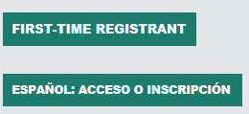  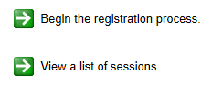
Create a User ID and Password you can easily remember.  This is necessary for all participants. This establishes your account with the VIRTUS program. If your preferred User ID is already taken, please choose another ID. We suggest the use of email addresses as usernames.  In light of the current health concerns, one prudent and preventative measure we can take is to make the VIRTUS Protecting God's Children training available Online as an option.  This is a temporary precaution which remain in effect through July 31, 2020. As the social isolation recommendations are updated, we will reevaluate the situation. All live sessions are cancelled until we determine it is safe to gather.  Click Continue to proceed. | 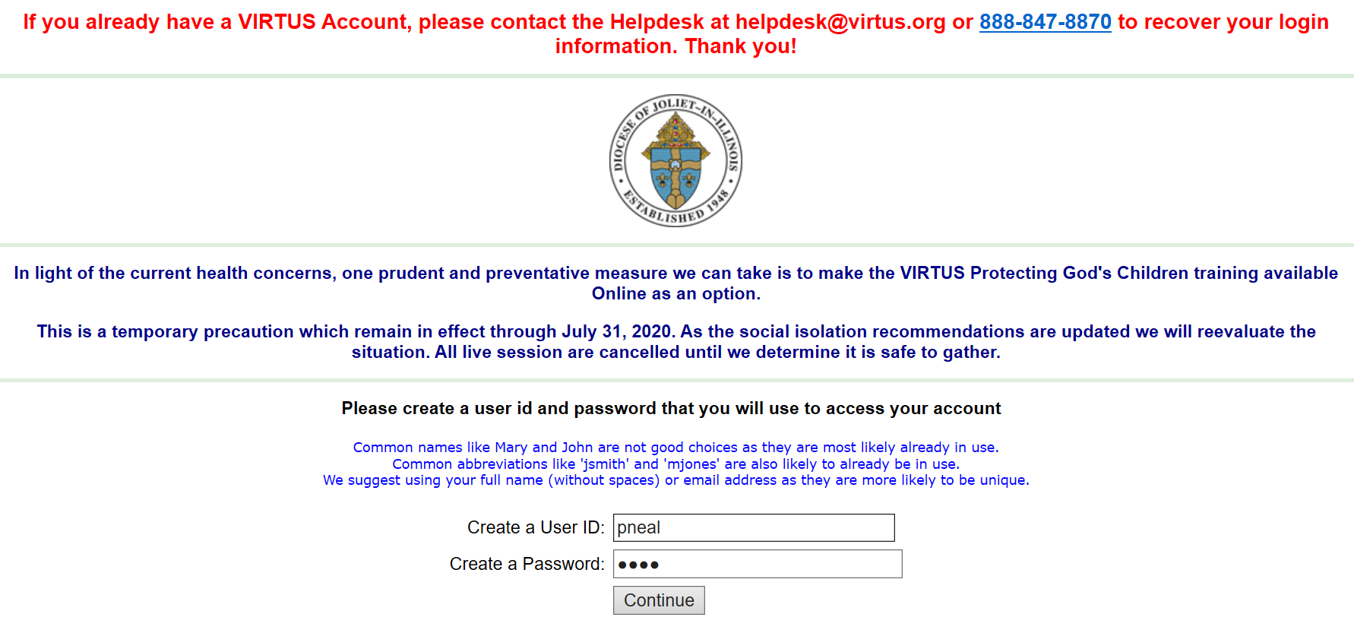
Provide all the information requested on the screen.  Several fields are required, including: First & Last Name, Email Address, Home Address, City, State, Zip, Phone Number, and Date of Birth.  (Note: Do not click the back button or your registration will be lost.)  Click Continue to proceed.  If you do not have an email address, consider obtaining a free email account at mail.yahoo.com, or any other free service. This is necessary for your Safe Environment Coordinator to communicate with you. If you cannot obtain an email address, enter: noaddress@virtus.org. | 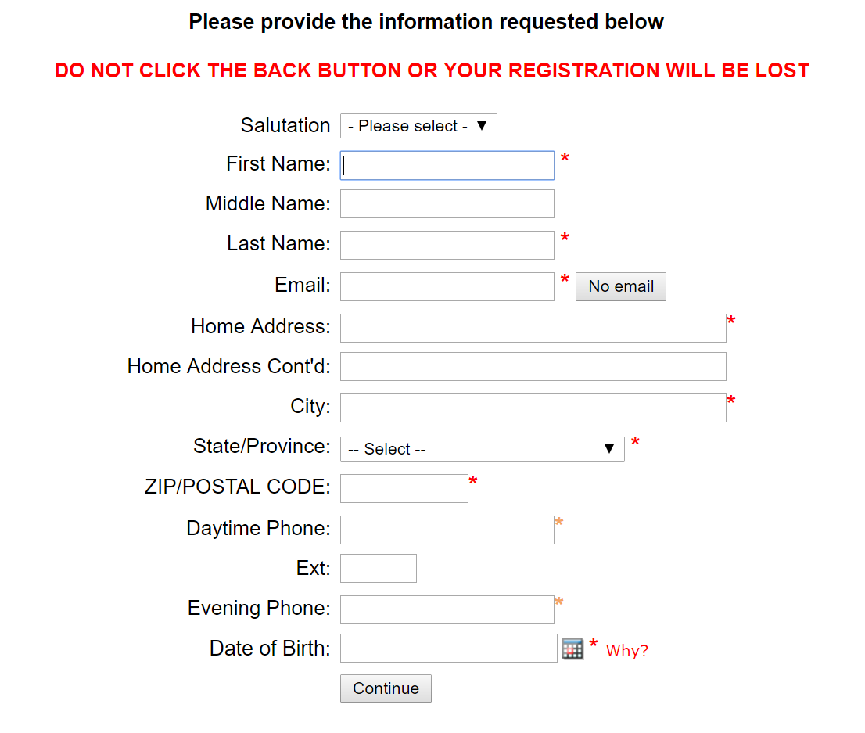
Select the PRIMARY location where you work or volunteer by clicking the downward arrow and highlighting the location.  Click Continue to proceed.  Note: If you serve at multiple diocesan locations, you will be prompted to select those additional locations in future screen(s). | 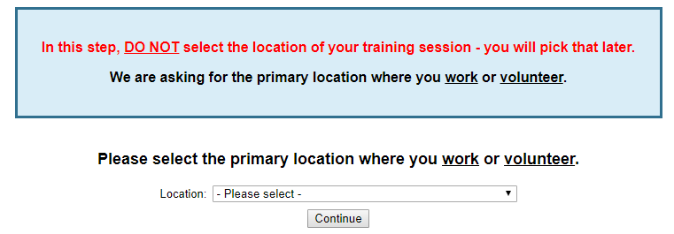
Your selected location(s) are displayed on the screen.  Please select the roles you perform at this location and enter a brief description of your title or position.  Select Continue to proceed.  If you are an Employee at a Parish or School, please select any additional roles.  If you are a Volunteer, please select any additional roles. | 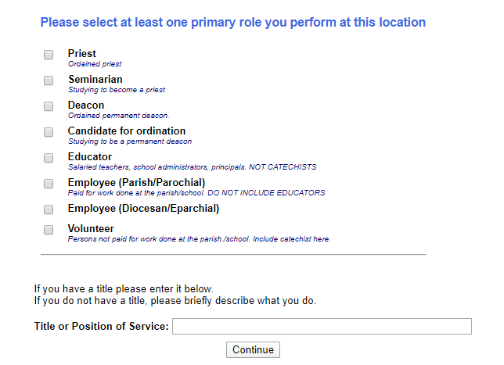  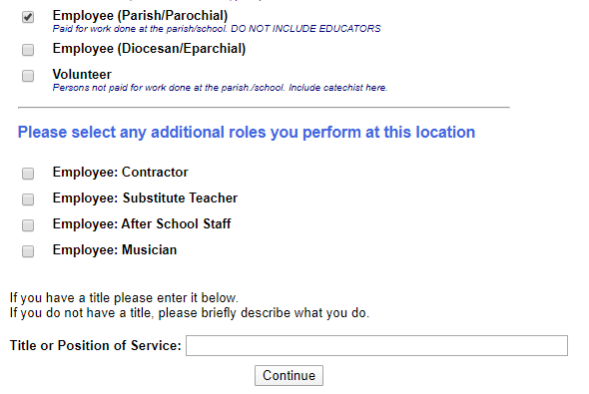  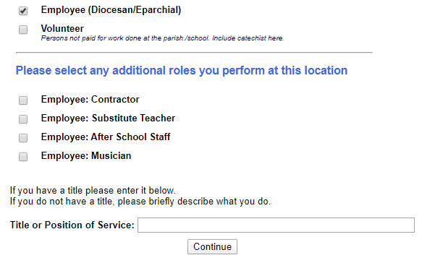  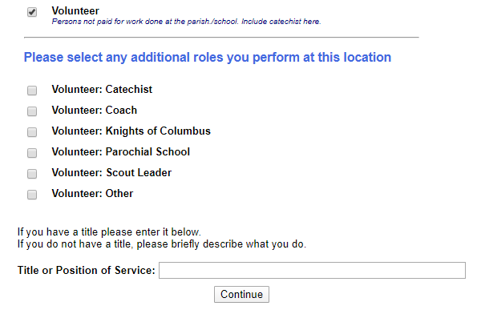
Select Yes if you are associated with any other locations.  Select No for no other locations.  . | 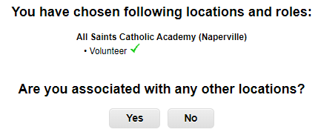
Please answer the three questions.  Click Continue to proceed. | 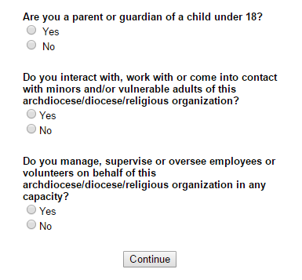
Please review the following and respond:  - Code of Policy Regarding Sexual Abuse of Minors  To proceed, please Confirm by clicking on: “I have downloaded, read, and understand these guidelines” and enter your full name and today’s date.  Click on Continue. | 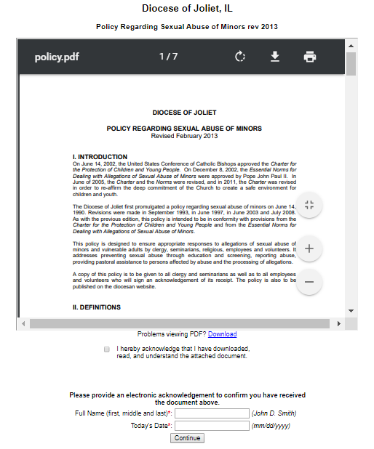
Please review the following and respond:  - Standards of Behavior to Safeguard Against Child Abuse  To proceed, please Confirm by clicking on: “I have downloaded, read, and understand these guidelines” and enter your full name and today’s date.  Click on Continue. | 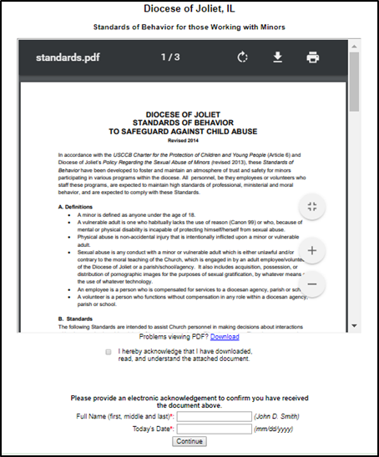
If you have not attended a VIRTUS Protecting God’s Children session, choose NO.  Otherwise, choose YES. | 
If you chose NO during the previous step, you will be presented with a list of upcoming VIRTUS Protecting God’s Children instructor led and online sessions scheduled for the Diocese of Joliet.  When you find the session training you wish to attend, click the circle -- and then click Complete Registration.  (If you chose YES during the previous step, you will be presented with a list of all instructor led VIRTUS sessions conducted in the Diocese of Joliet. Choose the session you attended by clicking the downward arrow and highlighting the session -- then click Complete Registration.) | 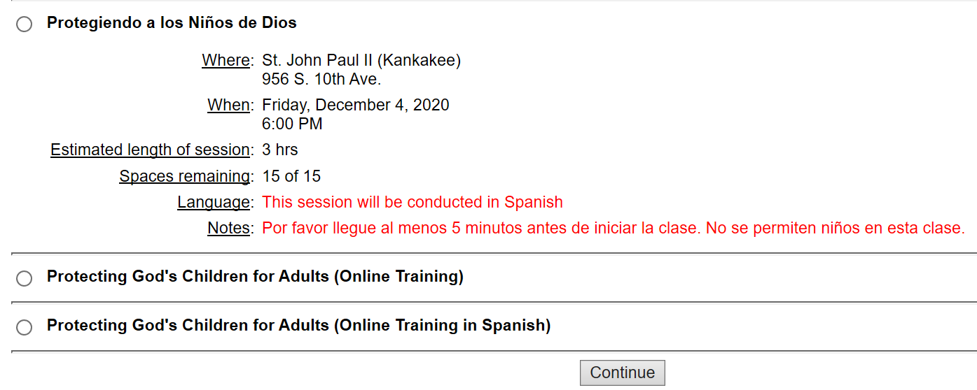
As part of our efforts to create and maintain a safe environment for children, volunteers and staff we must conduct a criminal background check.  If you are a NEW EMPLOYEE/APPLICANT, please contact the hiring manager for instructions to be fingerprinted. Please click ‘Go To Training’ and the online training will be accessible if chosen as the selected training.  If you are a VOLUNTEER or CONTINUING EMPLOYMENT follow the instructions to conduct a name-based background check through Selection.com website. | 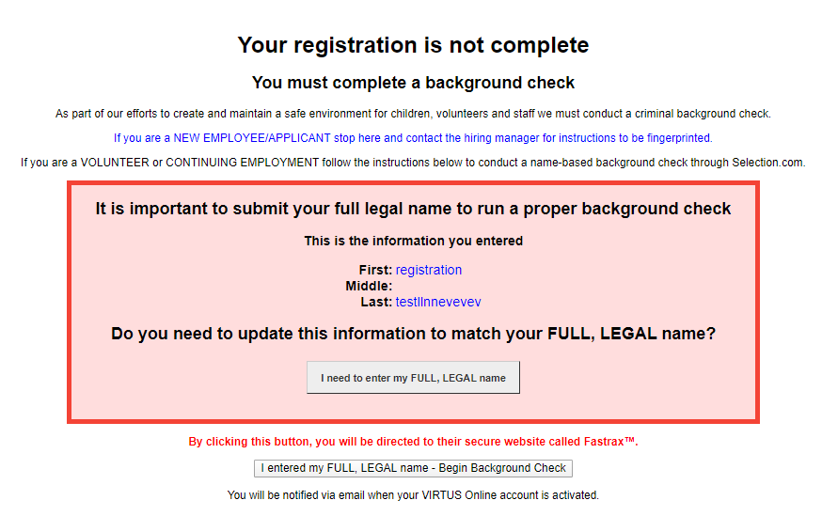
You are now within the secure website of FASTRAX®. Please click on Enter Background Check Info to proceed.  Please complete the steps within the background check process, which includes reviewing the inquiry release, entering applicant information, a final review, and the submission of the background check  After you attend the training session, you will receive an email of approval. | 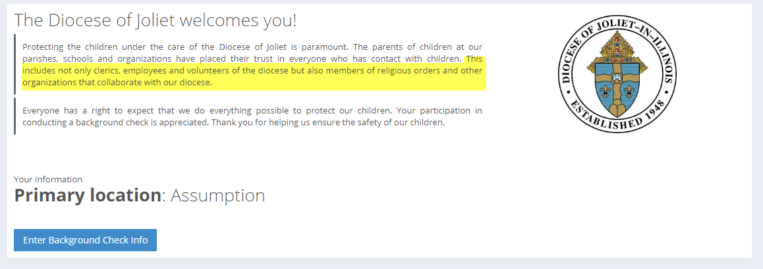
If you selected online training, please click on the green circle to begin the Online Training  Upon completion, the last screen will allow you to print a certificate, and you will always have the ability to log back into your account and access the certificate. | 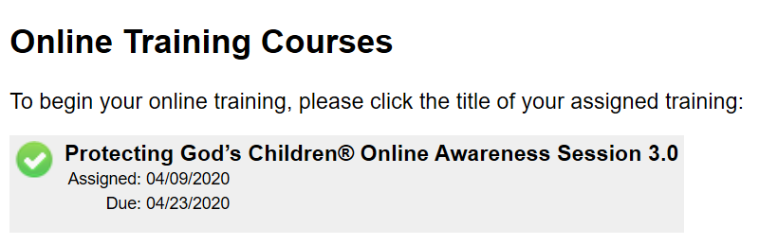
If you have additional questions about VIRTUS Online training, please contact the VIRTUS Help Desk at 1-888-847-8870.  To contact the background check provider, Selection.com, please contact their helpdesk at 800-325-3609.  Thank you for completing the registration process! | 

